Activity 3.2: Asking your name
Program the cat to ask the user their name and then output Hello, followed by the user’s name, followed by, nice to meet you!.
Here are the blocks you need to create the program. You need to find these blocks and make the program work.
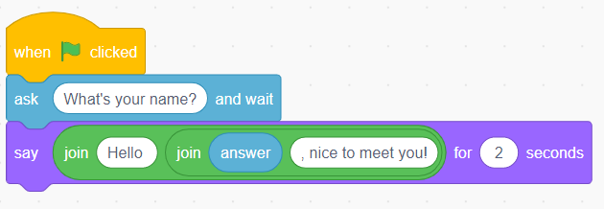
Don’t forget to screenshot your blocks and paste the screenshot into your evidence document.
Extension activity
Can you program the cat to ask a second question and give an appropriate response?
Remember to screenshot your blocks and paste the screenshot into your evidence document.

